REQUEST FOR PROPOSALS

Purchase, Installation, and Operation of Public Electric Vehicle (EV) Charging Stations in the

Towns of Dunstable and Pepperell, Massachusetts

SCHEDULE

RFP released: | March 4, 2024
Site Visit date: | April 9, 2024, beginning at 9:00 am,  511 Main Street, Dunstable, MA 01827
Questions due: | Wednesday, April 17, 2024 at 5:00 pm
Answers to questions posted: | Thursday, April 25, 2024
Proposals due: | Thursday, May 9, 2024 at 5:00 pm

QUESTIONS
All questions regarding this Request for Proposals (RFP) should be directed to: Meghan Tenhoff, Sustainability Planner II, NMCOG at mtenhoff@nmcog.org

SUBMISSION
Please submit bids by Thursday, May 9, 2024 at 5:00 PM EST to: mtenhoff@nmcog.org

RFP advertised at: nmcog.org
Dunstable-ma.gov, Town-Pepperell.ma.us, & COMMBUYS
Table of Contents
Section 1: Introduction 1
Public Access Charging (PAC) Program 3
Overview and Background 3
Budget 3
Section 2: Statement of Work 4
Project Scope and Timeline 4
Project Tasks 4
Task 1: Upgrade Electric Supply and Construction 4
Task 2: Install Charging Stations 4
Section 3: Content for Proposals 5
Experience and Qualifications 5
Community Benefits and Cost Recovery 6
Cost for Charging Station(s) 6
Section 4: Submission and Administration 6
Submission 6
Conditions and Limitations 6
Selection Criteria: 7
ATTACHMENT A: Certificate of Non-Collusion 9
Attachment B: Tax Compliance Certification 10

Page i

Section 1: Introduction

The Towns of Dunstable and Pepperell, Massachusetts are inviting proposals to enhance public charging infrastructure, aiming to accelerate the adoption of electric vehicles (EVs) in alignment with our region's greenhouse gas reduction objectives. This Request for Proposals (RFP) aims to take tangible steps by fostering partnerships and utilizing the Towns' properties to broaden EV charging accessibility in Dunstable and Pepperell. The Towns are seeking installation of stations on the following properties:

Figure 1: Location of energy source and potential EV Charging Station(s) for the Town of Dunstable, Dunstable Town Hall, 511 Main Street, Dunstable, MA 01827

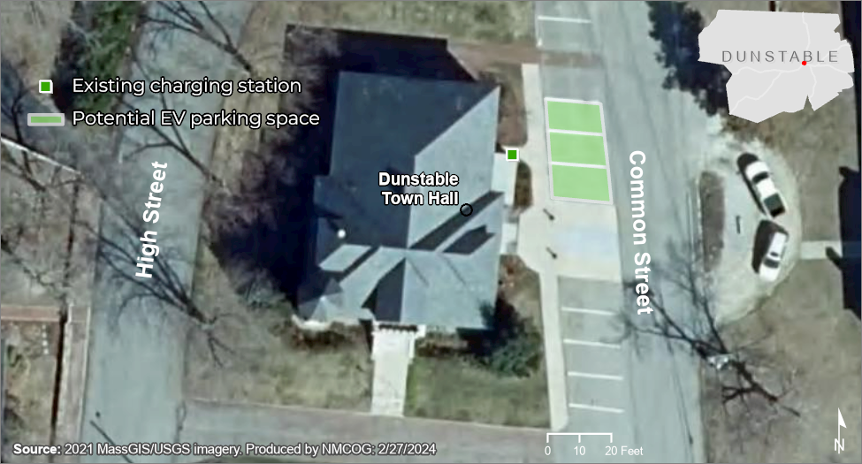
Energy Source
Figure 2: Existing Energy Source Location and Potential EV Charging Station Location(s) for the Town of Pepperell, 45 Main St, Pepperell, MA 01463.
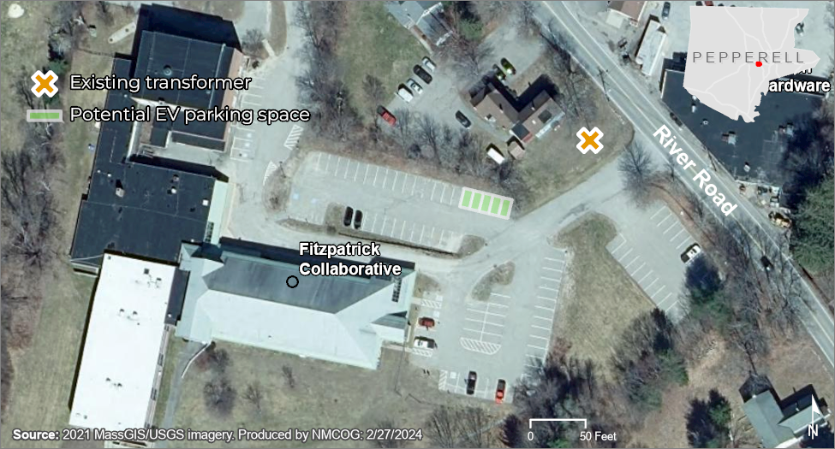

Figure 3: Location of Energy Source and Potential EV Charging Station(s) for the Town of Pepperell, Pepperell Community Center, 4 Hollis St, Pepperell, MA 01463.
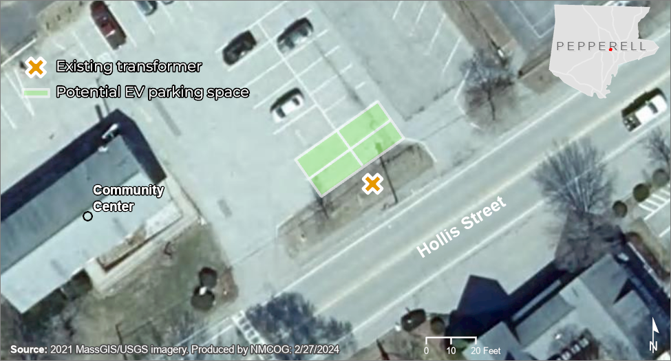

Public Access Charging (PAC) Program
The EV charging stations are being installed under the Massachusetts Electric Vehicle Incentive Program (MassEVIP) Public Access Charging (PAC) Program, administered by the Massachusetts Department of Environmental Protection (MassDEP). The program offers incentive funding to property owners or their representatives within the Commonwealth. The program aims to cover a portion of the costs associated with installing efficient and compatible EV charging stations accessible to the general public.

This project will fund the purchase and installation of EV charging stations on municipal properties in the two towns. The partner will register the EV charging stations to the United States Department of Energy’s (DOE) Alternative Fuels Data Center Station Locator http://www.afdc.energy.gov/fuels/electricity_locations.html, market the EV charging station to the general public, and provide pricing for operation and maintenance EV charging stations for three (3) full consecutive years after the date the charging station is operational in accordance with PAC.

Overview and Background
Dunstable and Pepperell are working to promote climate resiliency, the adoption of EVs is a component of that work. Both towns are committed to facilitating access to public charging options within their communities. Funding was secured for the Towns of Groton, Dunstable, and Pepperell through a special obligation by the Commonwealth. The two towns decided to purchase and install CoRE + L2 Charging Stations or comparable dual-port EV charging stations at municipal-owned properties in each community. The Towns are seeking proposals from third parties to sell and install EV charging stations in the Town(s) and provide pricing for the operation and maintenance of those charging stations.

The Towns seek a public-private partnership whereby the Town(s) would purchase, and a third­party would install, operate, and maintain, electric vehicle charging infrastructure at
- Town of Dunstable, Town Hall, 511 Main Street, Dunstable, MA 01827
- Town of Pepperell, Fitzpatrick Collaborative, 45 Main St, Pepperell, MA 01463
- Town of Pepperell, Pepperell Community Center, 4 Hollis St, Pepperell, MA 01463
A map showing the energy source and potential locations is on pagesPar 1 and 2.

Installation includes any underground service connections and any upgrades in the electric supply. All work must comply with MassEVIP guidelines for the PAC program.

This RFP will generate a short list of prospective private partners with whom the Towns may engage in more detailed negotiations. The final award is expected based on the proposal that provides the greatest overall community benefit and value to the Towns. Dunstable anticipates entering into a License Agreement with the selected partner but is open to alternatives compatible with local and state laws. The Towns reserve the right to reject any or all proposals that do not sufficiently meet the Towns’ stated needs.

Budget
$42,000 is available toward the purchase and installation of EV charging stations/ports including the installation of necessary electrical infrastructure for the charging stations. Additional funds may become available to fund future EV charging infrastructure.

Section 2: Statement of Work

Project Scope and Timeline
The project will begin upon contract execution and once all local reviews and permits are in place as needed. The project close out must be completed by December 31, 2024. All respondents to this RFP shall have a working knowledge and be familiar with EV charging stations and related infrastructure. The partner may add any additional pertinent information to the scope as their experience and expertise determine within the allowable budget. This project will follow all required plan components and guidelines as stated on the MassEVIP PAC Program Requirements webpage, https://www.mass.gov/doc/massevip-public-access-charging-requirements/download.

Project Tasks

Task 1: Upgrade Electric Supply and Construction
Collaborate with Town staff, utilities, and energy suppliers for utility and construction work. Tasks may include:
- Upgrade electric supply;
- Install all required electrical elements to code (Massachusetts Electrical Code) including but not limited to underground service connections and the installation of any required secondary wires, poles, panels, meter sockets, and accessories;
- Construction related to installation (including ADA EV parking space);
- Any required bollards, bumper guards, or other local requirements per historic districts or other design criteria that must be upheld for installation; and
- Any signage and pavement painting.

Task 2: Install Charging Stations
Identify the appropriate charging station manufacturer for each of the three locations and provide all required materials for installation. Tasks and supplies may include:
- Review local review and permitting requirements and engage in any required local reviews.
- CoRE + L2 EV Charging Stations or comparable dual-port EV Charging Stations equipped with both CHAdeMO and Combined Charging System (CCS) connectors for each port, but otherwise neutral regarding the make and model of vehicles that can be charged;
- A console wired into the electrical supply;
- A cable and connector to plug into the EV;
- Cable management strategy (e.g., coil, retractable, etc.);
- Mounting, pedestal for charging station(s) and any required pedestal anchor kits;
- Separate payment module (must be able to provide payment option for all EV drivers without restrictions based on network membership or subscription (e.g., allow credit card payment without login);
- Available warranty options;
- Software options (allows the town to collect usage data and monitor peak charging times); and
- Stations must be capable of being included in station locator apps such as Alternative Fuels Data Center, PlugShare, and others. This will include information on the charging or fueling connector types and publicly available information on real-time availability and payment methods to ensure secure, convenient, fair, and equal access.

At a minimum, Dunstable and Pepperell are looking for the following from a partner:
- Purchase and installation of electric vehicle charging stations to Dunstable Town Hall, Pepperell’s Fitzpatrick Collaborative, and Pepperell Community Center referenced in this RFP.
- A quote that outlines all necessary costs of operation and maintenance, including network connectivity; the payment portal, collect fees for charging services directly from users, provide 24/7 technical support for installed EV charging sites, and ensure a minimum of 98% availability of the stations to the public for a three (3) year period.
- Revenue models to support the operation of chargers through access and utilization fees or other means such as ads on stations to generate revenue, and/or partnerships with third parties.
- Agreement of the fees to access and utilize charging stations. The goal is to keep stations accessible and affordable while also providing a reasonable economic return to the partner.

Additionally, the Towns reserve the right to place reasonable restrictions on outdoor advertising, including location and content and must approve all content on ads and/or third-party agreements. Further, respondents should note the requirements of each towns’ zoning bylaws regarding signage. Per the Pepperell Zoning Bylaw Section 5340: Moving, animated, revolving, moving light, or flashing sign or sign elements are not permitted. Per the Dunstable Zoning Bylaw Section 13.4 illumination shall only be allowed by reflected white light emanating from a source external to the sign proper (but which may be attached thereto). The source of light shall be steady, and shall be shielded from direct view at normal eye level from streets and from adjacent premises. The installation of bollards or other infrastructure may require further approvals by a local board in each respective community.

Section 3: Content for Proposals

Overview
Bidders must provide a single (1) proposal for each Town’s EV charging stations purchase, installation, and operation and maintenance:
- Describe the company's qualifications, experience, cost recovery strategy, and anticipated costs borne by the Towns and users of the EV charging stations.
- Describe how your company would select appropriate charging stations; provide details on installation requirements and associated costs; and provide charging station operation and maintenance; and
- Describe any other innovations, social, economic, or environmental benefits that demonstrates competitive advantage.

Experience and Qualifications
Describe your company or team experience and capability related to:
- Performing the contract and providing the products and services required;
- Experience in project management team implementing, maintaining, and operating networks of charging stations;
- Experience implementing similar projects (including securing funding, a sustainable business model, and completing the entirety of the scope of a project similar to that proposed here) in coordination with a local government or public entity;
- Historical performance in terms of number of users, uptime of charging stations, etc.; and
- Demonstrated proof of financial stability.

Community Benefits and Cost Recovery
Describe your company’s cost recovery strategy and anticipated costs borne by the Towns and users of the EV charging stations by including the following:
- Describe and provide a cost estimate for your company to provide charging station operation and maintenance for a three-year period including network fees, payment systems/portal, collection of fees from users, regular service/maintenance, estimated annual energy cost to the Towns, 24/7 technical support, and other associated costs;
- Provide a description of the process for renewal or extension of an operations and maintenance contract at the end of three years; and
- Describe any other innovations, social, economic, or environmental benefits that would separate the proposer from other market participants.

Cost for Charging Station(s)
- Provide the costs of the appropriate charging infrastructure for CoRE + L2 EV Charging Stations or comparable dual-port EV Charging Stations.
- Provide pricing for operations and maintenance for a three-year term.

Section 4: Submission and Administration
The Towns are subject to M.G.L. Chapter 30B for bids.

Submission
Each submittal should include a cover letter and single point of contact (name, title, phone number and email address) and concisely address all content outlined in Section 3 of this RFP. All materials must be submitted via email, including the Certificate of Non-Collusion and the Tax Compliance Certification found in Attachments A and B.

Conditions and Limitations
The Towns reserve the right, in their sole and absolute discretion, to reject any and all submissions received in response to this request, advertise for new submissions or to accept any proposal deemed to be in its best interest, to suspend negotiations, and to cancel this request at any time, for any or no reason, prior to entering into a formal contract. The Towns further reserve the right to request clarification of information provided in submissions in response to this request without changing the terms of this request.

A proposal submitted in response to this request does not constitute a contract and does not indicate or otherwise reflect a commitment of any kind on behalf of the Towns or impose any binding obligations on the Towns or grant any rights to any party making a submission. Furthermore, this request does not represent a commitment or offer by the Towns to enter into an agreement with any submitter or to pay any costs incurred in the preparation of a proposal to this request. Furthermore, this request does not commit the Towns to pay for costs incurred in the negotiation or other work in preparation of, or related to, a final agreement between the selected proposer and the Towns. Any commitment made by the Towns will be subject to local and state laws.
The submissions and any information made a part of the submissions will become a part of the project's official files. The Towns are not obligated to return any materials submitted or received in response to this request. This request and the selected submitter's response to this request may, by reference, become a part of any formal agreement between the submitter and the Towns.

If any part of your proposal is proprietary or confidential and, therefore, is limited to disclosure under state law, the submitter must identify all information that is confidential or proprietary and provide justification for why such materials should not be disclosed by the Towns under state law. The Towns, as custodian of submissions submitted in response to this RFP, reserve the right to determine whether or not material deemed proprietary or confidential by the submitter is, in fact, proprietary or confidential as required by state law, or if state law permits nondisclosure. The Towns will favor disclosure of all submissions in response to any request for disclosure made under the Massachusetts Public Records Law, M.G.L.Ch. 66, Sec. 10.

By submitting a proposal, the proponent agrees that, if selected, they will sign a standard contract substantially in the form provided in Appendix B.

Selection Criteria:
The Towns will award the contract to the bidder offering the most advantageous proposal to this RFP, taking into consideration all quality requirements and comparative criteria set forth in the RFP as well as price. The selection process will include an evaluation based on the criteria identified below. The Towns reserve the right to conduct interviews as part of the selection process.

Experience purchasing and installing EV Charging Stations (i.e., model identification, electric connection, and construction)

Extremely Advantageous: Company has at least seven years of selecting appropriate EV charging stations and experience with installation of networked electric vehicle charging stations.

Advantageous: Company has at least five years of experience selecting appropriate EV charging stations and experience with installation of networked electric vehicle charging stations.

Not Advantageous: Company has fewer than five years of selecting appropriate EV charging stations and experience with installation of networked electric vehicle charging stations.

Experience operating networked (i.e., connected to a wireless or wired computer network for purposes or monitoring and operation) charging stations.

Extremely Advantageous: Company has at least seven years of experience operating networked electric vehicle charging stations.

Advantageous: Company has at least five years of experience operating networked electric vehicle charging stations.

Not Advantageous: Company has fewer than five years of experience operating networked electric vehicle charging stations.

Proof of Partner financial stability

Extremely Advantageous: Strong financial stability as reflected in a certified financial statement or other certified statement, including but not limited to a Dun and Bradstreet financial rating.

Advantageous: Financial stability as reflected in a certified financial statement or other certified statement, including but not limited to a Dun and Bradstreet financial rating.

Not Advantageous: Certified financial statement or other certified statement, including but not limited to a Dun and Bradstreet financial rating, does not show evidence of financial stability/financial stability not demonstrated.

Demonstrated ability to provide EV charging stations with robust network compatibility with a variety of map location, equipment status, and payment systems (e.g., PlugShare, ChargeHub, Chargemap, etc.)

Extremely Advantageous: EV charging station model and operation and maintenance proposal includes robust network compatibility with a variety of leading location mapping and equipment status (availability, repair status, usage cost) systems, and allows payment by all EV drivers without restrictions based on network membership or subscription (e.g., allows credit card payment without login).

Advantageous: EV charging station model and operation and maintenance proposal includes robust network compatibility with a variety of leading location mapping and equipment status (some but not all of these: availability repair status, usage cost) systems, and allows payment by all EV drivers without restrictions based on network membership or subscription (e.g., allows credit card payment without login).

Not Advantageous: EV charging station model and/ or operation and maintenance proposal does not include demonstrated network compatibility and/ or does not enable payment by all EV drivers without restrictions based on network membership or subscription or requires membership fees in addition to usage fees.

Attachment A: Certificate of Non-Collusion

The undersigned, having been fully informed regarding the accuracy of the statements made herein, certifies that:

- This Qualifications Package was developed and submitted independently and without consultation, communication, collusion, understanding, or agreement with any other Respondent or potential Respondent.

- No attempt has been made or will be made to induce any firm or person to refrain from bidding on this contract.

- This Qualifications Package is made in good faith and not pursuant to any agreement or discussion with, or inducement from, any firm or person to submit a complementary or other noncompetitive application.

- (name of firm), its affiliates, subsidiaries, officers, directors and employees are not currently under investigation by any governmental agency and have not, in the last five years, been convicted of or found liable for any act prohibited by state or federal law in any jurisdiction, involving conspiracy or collusion with respect to bidding on any public contract.

The undersigned attests that they are authorized to make this certification on behalf of the Respondent, and its owners, directors, and officers.

Name and Title/Position of Signatory Signature

Name of Respondent/Firm Date

Attachment B: Tax Compliance Certification

Pursuant to M.G.L. c. 62C, §49A, I certify under the penalties of perjury that, to the best of my knowledge and belief, I am in compliance with all laws of the Commonwealth relating to taxes, reporting of employees and contractors, and withholding and remitting child support.

___________________________________________
Signature of Person Submitting Bid

___________________________________________
Name of Business

The Town of Groton declined participation in this project.

